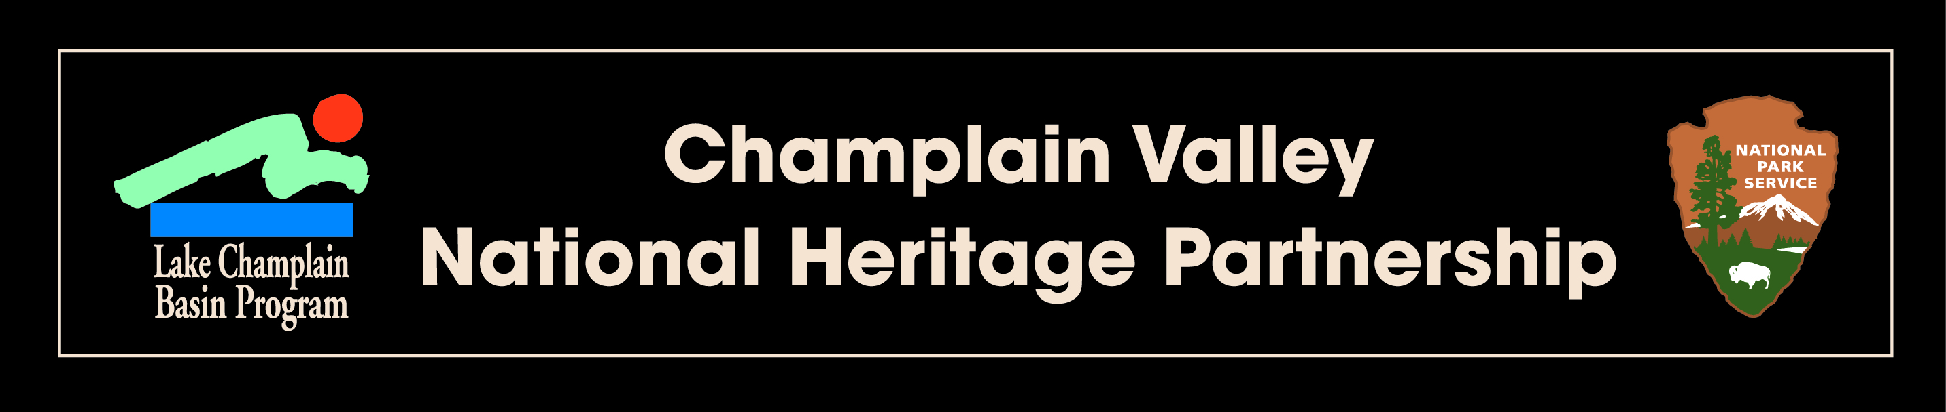

Final Report

|  |  |
| --- | --- |
| NEIWPCC Job Code:  Project Code: | 988-014  [Located on your contract] |
| Date Submitted:  Date Approved: | [ e.g. December 31, 2019] |

|  |
| --- |
|  |

ished by

[Final Report Title]

**Contact Information**

──────────────────────────────────────────────────────────────────

(Name)

(Title)

(Organization)

(Mailing Address)

(Telephone Number)

(E-mail Address)

This is a **Champlain Valley National Heritage Partnership** funded project

Lake Champlain Basin Program

54 West Shore Road

Grand Isle, VT 05458

802.372.3213

[www.cvnhp.org](http://www.cvnhp.org)

**(Please remove all explanation text in green prior to submittal.)**

**(Note: all non-title text should be:** black, Times New Roman, 12-point font)

# This project was funded by an agreement awarded by the Great Lakes Fisheries Commission (GLFC) to the New England Interstate Water Pollution Control Commission (NEIWPCC) in partnership with the Lake Champlain Basin Program. NEIWPCC manages LCBP’s personnel, contract, grant, and budget tasks and provides input on the program’s activities through a partnership with the LCBP Steering Committee.

# Although the information in this document has been funded wholly or in part by the NPS under an agreement between the NPS and NEIWPCC. It has not undergone the NPS publications review process and therefore, may not necessarily reflect the views of the NPS and no official endorsement should be inferred. The viewpoints expressed here do not necessarily represent those of NEIWPCC, the LCBP Steering Committee, or NPS, nor does mention of trade names, commercial products, or causes constitute endorsement or recommendation for use.

# Executive Summary

# Project Synopsis

[Please provide a synopsis of the final report (**no more than 150 words**) that includes your organization, project location, actions, timeframe, and results/accomplishments. Note that this should be an independent abstract of your report and should not contain information that is not already provided in the main body of the report.]

# Output

[An **output** is an activity or product generated as a result of a task (e.g. developing an interpretive display, training an intern, installing a new HVAC system in a museum, etc.). **Output statements should be no more than 20 words**.]

# Outcome

[An **outcome** is a result or effect of all activities (e.g. increased public awareness of the Suffrage Movement, students who better understand the historical significance of their community, etc.). **Outcome statements should be no more than 20 words**.]

**CVNHP Management Plan Action ID**

The project supported the following task(s) of the [CVNHP Management Plan](http://www.champlainvalleynhp.org/PDFs/FINAL_CVNHP_MgmtPlan_with_%20OFAlinks_092311.pdf):

[These are listed in your project workplan. Please display as follows:

* **Task 9.1.2:** Support ethnographic research and documentation of the cultures within the CVNHP.
* **Task 9.11.2:** Encourage youth cultural and education exchanges.
* **Task 9.12.7:** Provide CVNHP-related presentations to schools.
* **Task 9.18.1:** Support bilingual interpretation of resources within the CVNHP.]

# Table of Contents

**Page**

Executive Summary 3

1 Project Introduction 5

2 Tasks Completed 6

3 Deliverables Completed 7

4 Conclusions 8

5 References and Appendices 9

# Project Introduction

[Provide a description of your project, including its purpose and goals; include information about the role of any partnering organizations. Your introduction should elaborate the need for the work accomplished in the project.]

# Tasks Completed

[Provide a description of the tasks completed to achieve the goal(s) of the project. Tasks include accomplishments such as programs delivered, equipment installation, etc. Please add pictures or maps as appropriate. These tasks should closely align with the tasks identified in your approved project workplan.]

# Outcomes/Deliverables Completed

[Provide a description of all completed deliverables, as indicated in the project workplan, and their timeframe of completion. Explain any problems encountered and their respective solutions (if applicable). Include all relevant graphs, tables and photographs.]

# Conclusions

[Provide a summary of project accomplishments, lessons learned, and possible future work to support the implementation of the *CVNHP Management Plan and* the LCBP’s *Opportunities for Action*.]

# References and Appendices

Required Documentation (Attach any articles, press releases (which should acknowledge partnership with LCBP), a list of acronyms and published documents pertaining to this project.):

* Press release announcing grant award and describing project.
* Digital copies of (or electronic links to) any media coverage the project.
* At least three (3) digital photos (in largest format available) of people participating in activities relating to the grant.
* Include this table as deliverables (NOTE: please use “N/A” if not applicable to your project.

|  |  |
| --- | --- |
| Deliverable | Amount |
| Total number of **volunteers** engaged in project |  |
| Total number of **volunteer hours** |  |
| **Value of volunteer hours** (Hourly rates: NY: $30.18; VT: $26.40; QC: $27.39) |  |
| Number of grant-funded **events** |  |
| Number of **people attending grant-funded events** |  |
| Education: Number of **students** involved |  |
| Education: Number of **teachers/specialists** involved |  |
| Education: Number of **classes/field trips/etc.** |  |

**Photos:** Email or mail a CD to your Project Officer with any photo documentation you have of your project with proper photo credit that LCBP can use in future publications.

**Electronic Data:** Email or mail a CD to your Project Officer with any electronic datasets you have generated through your project.

Attach any articles, press releases (which should acknowledge partnership with LCBP), a list of acronyms and published documents pertaining to this project.

**NOTE:** Please submit this report as a Microsoft Word Document. Google Docs, PDFs, paper copies, or any other format will be rejected by the project officer.