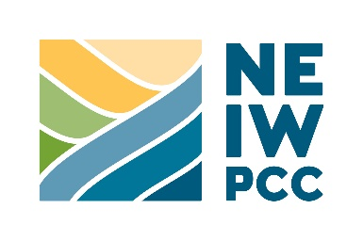
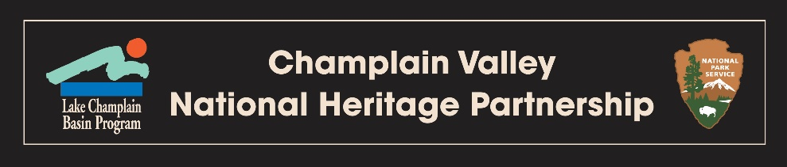

Final Report

NEIWPCC Job Code:  Project Code: | [Located on your contract]  [Located on your contract]
Date Submitted:  Date Approved: | [ e.g. December 31, 2026]

ished by

[Final Report Title]

Contact Information
──────────────────────────────────────────────────────────────────
(Name)
(Title)
(Organization)
(Mailing Address)
(Telephone Number)
(E-mail Address)

This is a Champlain Valley National Heritage Partnership funded project
Lake Champlain Basin Program
54 West Shore Road
Grand Isle, VT 05458
802.372.3213
www.cvnhp.org

(Please remove all explanation text in green prior to submittal.)
(Note: all non-title text should be: black, Times New Roman, 12-point font)

This project was funded by an agreement awarded by the Great Lakes Fishery Commission (GLFC) to the New England Interstate Water Pollution Control Commission (NEIWPCC) in partnership with the Lake Champlain Basin Program. NEIWPCC manages LCBP’s personnel, contract, grant, and budget tasks and provides input on the program’s activities through a partnership with the LCBP Steering Committee.

Although the information in this document has been funded wholly or in part by the GLFC under an agreement between the GLFC and NEIWPCC. It has not undergone the GLFC publications review process and therefore, may not necessarily reflect the views of the GLFC and no official endorsement should be inferred. The viewpoints expressed here do not necessarily represent those of NEIWPCC, the LCBP Steering Committee, or GLFC, nor does mention of trade names, commercial products, or causes constitute endorsement or recommendation for use.

Questions to Ask Yourself Before You Begin:
- Did you issue a press release for this project? A press release is required for project approval—please include copy of press release or a screenshot from your website in References and Appendices section below.
- Did you file quarterly reports (due on January 1, April 1, July 1, and October 1) during the period of the grant? Please double-check this requirement before submitting the final report.
- Did you receive media coverage of the project? If so, please submit links and screenshots of the coverage in the References and Appendices section below.
- Did have at least three individual digital photo attachments in highest resolution and size possible? Required—please send them as individual files appropriately (e.g. “LS-2025-007 Smithsonian Archeology Photo #”) and embed them in the References and Appendices section below.
- Did you complete a Match Certification Form? Required as separate document labeled appropriately (e.g. “LS-2025-007 Smithsonian Archeology Match Certification”).

Executive Summary

Project Synopsis
[Please provide a synopsis of the final report (no more than 150 words) that includes your organization, project location, actions, timeframe, and results/accomplishments. Note that this should be an independent abstract of your report and should not contain information omitted in the main body of the report. Please avoid personal possessive pronouns (i.e. “our,” “we,” etc.); refer to your organization in the “third person” (e.g. instead of “we received a grant” use “the museum received a grant” instead). Note: Please use this style throughout the report.]

Output
[An output is an activity or product generated because of a task (e.g. developing an interpretive display, training an intern, installing a new HVAC system in a museum, etc.). Output statements should be no more than 50 words. DO NOT include a bulleted list.]

Outcome
[An outcome is a result or effect of all activities (e.g. increased public awareness of the Suffrage Movement, students who better understand the historical significance of their community, etc.). Outcome statements should be no more than 50 words. DO NOT include a bulleted list.]

CVNHP Management Plan Action ID
The project supported the following task(s) of the CVNHP Management Plan:
[These are listed in your project workplan. Please display as follows:
- Task 9.1.2: Support ethnographic research and documentation of the cultures within the CVNHP.
- Task 9.11.2: Encourage youth cultural and education exchanges.
- Task 9.12.7: Provide CVNHP-related presentations to schools.
- Task 9.18.1: Support bilingual interpretation of resources within the CVNHP.]

NOTE: DO NOT editorialise on the task. Simply include the tasks as listed in the CVNHP Management Plan.]

Table of Contents

Page

Executive Summary 3
1 Project Introduction 5
2 Tasks Completed 6
3 Deliverables Completed 7
4 Conclusions 8
5 References and Appendices 9

Project Introduction
[Provide a description of your project, including its purpose and goals; include information about the role of any partnering organizations. Your introduction should elaborate the need for the work accomplished in the project. Please do not include hyperlinks to the project in your project introduction.]

Tasks Completed
[Provide a description of the tasks completed to achieve the goal(s) of the project. Tasks include accomplishments such as programs delivered, equipment installation, etc. Please add pictures or maps as appropriate. These tasks should closely align with the tasks identified in your approved project workplan.]

Note: If your narrative includes a hyperlink, please include a screenshot of the connected website in a separate document labeled appropriately (e.g. “LS-2025-007 Smithsonian Archeology Hyperlink for Task 1”).

Project Task Outline and Timetable Deliverables

Task 1: [Insert text and, if applicable, links with screenshots here]

Task 2: [Insert text and, if applicable, links with screenshots here]

Task 3: [Insert text and, if applicable, links with screenshots here]

Task 4: [Insert text and, if applicable, links with screenshots here]

[Add more task sections as appropriate]

Deliverables Completed
[Provide a description of the deliverables associated with the goals and tasks of the project. Deliverables are listed on the project workplan’s Project Task Outline and Timetable and Other Project Deliverables questionnaire include accomplishments such as programs delivered, equipment installation, etc. Please add pictures or maps as appropriate.]

Note: If your narrative includes a hyperlink, please include a screenshot of the connected website in a separate document labeled appropriately (e.g. “LS-2025-007 Smithsonian Archeology Hyperlink for Deliverable 1”).

Project Task Outline and Timetable Deliverables

Task 1 Deliverables: [Insert text and, if applicable, links with screenshots here]

Task 2 Deliverables: [Insert text and, if applicable, links with screenshots here]

Task 3 Deliverables: [Insert text and, if applicable, links with screenshots here]

Task 4 Deliverables: [Insert text and, if applicable, links with screenshots here]

[Add more task sections as appropriate]

Metrics Table (Required—NOTE: please use “0” (zero) if not applicable to your project.)
Volunteer  Data | Volunteer  Data | Volunteer  Data | Events Data | Events Data | Education Data | Education Data | Education Data
Number of volunteers engaged in project | Number of volunteer hours | Value of volunteer hours* | Number of grant-funded events | Attendance at grant-funded events | Number of students involved | Number of teachers/  specialists involved | Number of classes/  field trips/ etc.
*2026 Hourly rates: NY: $39.50; VT: $35.53; QC: $37.52 (check with CVNHP staff for future values)

Conclusions
[Provide a summary of project accomplishments, lessons learned, and possible future work to support the implementation of the CVNHP Management Plan and the LCBP’s Opportunities for Action.]

Note: If your narrative includes a hyperlink, please include a screenshot of the connected website in a separate document labeled appropriately (e.g. “LS-2025-007 Smithsonian Archeology Hyperlink 1”).

References and Appendices
Required Documentation (Attach any articles, press releases (which should acknowledge partnership with CVNHP), a list of acronyms (if applicable), photos, and published documents pertaining to this project:

- Press release announcing grant award and describing project.

- Digital copies of (or electronic links to) any media coverage the project. Include any articles, press releases (which should acknowledge partnership with the CVNHP). Note: If your narrative includes a hyperlink, please embed a screenshot of the connected website below.

- At least three (3) digital photos (in largest format available) of people participating in activities relating to the grant. These should also be sent as independent files, labeled appropriately (e.g. “LS-2025-007 Smithsonian Archeology Hyperlink 1”), regardless if they are embedded in a report or email.

NOTE: Please submit this report as a Microsoft Word document. Please note: Google Docs, PDFs, paper copies, or any other format will be rejected by the project officer.

